Matlab program for hybrid wPSOGSA

1-D Magnetotelluric Inversion program

In MATLAB

Mukesh Mukesh, Kuldeep Sarkar, Upendra K. Singh

Indian Institute of Technology (Indian School of Mines), Dhanbad

[**mukesh.18dr0086@agp.iitism.ac.in**](mailto:mukesh.18dr0086@agp.iitism.ac.in) **,** [**kuldeepsarkar39@gmail.com**](mailto:kuldeepsarkar39@gmail.com) **,** [**upendra@iitism.ac.in**](mailto:upendra@iitism.ac.in)

**1. Overview of MT 1D Hybrid wPSOGSA Matlab code**

Hybrid wPSOGSA is a matlab code for inversion of 1D MT data applied over various noisy free, noisy synthetic data and field MT data. Minimizing the cost function defined as RMS error between observed and calculated data and find the best fit model and calculated the Bayesian probability density function to estimate the optimum solution

**2. Installation and usage of the code**

The provided Matlab code is generated (modified) in MATLAB R2020a. In Workstation, Intel(R) Xeon(R) CPU E3-1225 v6 @ 3.30GHz processor, 32.0 GB RAM and 64-bit Operating System ,x64-based processor.

**Note:** The Matlab codes (i.e. .m files) have also been provided in .dat format.

The following steps will help the user to execute the code properly.

1. First to generate the synthetic data by executing **synthetic.m** file and save the data in “.dat” format for initially known layer parameter (resistivities, thicknesses and frequencies). User can modified the model by making changes in layer resistivity and thickness, and also can vary frequency range.

For three layer example,

frequencies=[0.0001 0.0004 0.0006 0.0009 0.001 0.004 0.006 0.009 0.03 0.05 0.08 0.1 0.5 0.9 1 3 5 10 20 50 60 80 100 200 800];

resistivities = [30000 5000 1000];

thicknesses = [15000 18000];

The observe data is save in file ‘obs_data11.dat’ which contain three column. First column is frequency, second column is apparent resistivity and third column is phase.

1. Load the synthetic data in the main file (psogsa_mt.m) using the command; load(‘filename.dat’)

For example: data = load('obs_data11.dat');

1. Make required changes in file **psogsa_mt.m** such as, number of iterations (Max_Iteration), number of models (run), search range (down and up), and number of agents/swarm (N) according to user’s requirement.

For example:

dataFrequencies =data(:,1);% 1./period; %% frequencies

r_obs= data(:,2);% observed apparent resistivity

p_obs= data(:,3);%observed apparent phase

N = 50; % Size of the swarm " no agents/particles "

Max_Iteration =1000; % Maximum number of "iterations"

dim=5;% No. of layer parameters.

run=10;% Number of computations/Models

down=[5000 1000 50 5000 10000];

up=[50000 10000 5000 25000 25000];

1. User can modify the cost function from the function file named **benchmark_functions.m**

Here, the root mean square error is used in determining the cost function.

1. Execute the program file **psogsa_mt.m** and the following output files needed to be saved for further analysis. The meaning of the files are described below:

gBestScore % best score/error after each run

gBest % best model after each run

GlobalBestCost % error at each iteration for a run

gbest1 % present best model at each iteration for a run

r_calPG % apparent resistivity for best model after each run

p_calPG % apparent phase for best model after each run

gbest_run % store best model for all run

gBestScore_run % store best score/error for all run

GlobalBestCost_run % store error at each iteration for all run

gbest1_run % store best model at each iteration for all run

r_cal_PG % store apparent resistivity for best model after each run

p_cal_PG % store apparent phase for best model after each run

[gbscore,indexPG]=min(gBestScore_run); % determine index number with respect to least error/cost function

Gbscore % minimum error out of all store best score

indexPG % index of the minimum error out of all stored best score

gbestmodel % store best model w.r.t. index number ‘indexPG’

globalbestcost % store error at each iteration for index number ‘indexPG’ from GlobalBestCost_run

gbest11 % store best model at each iteration for index number ‘indexPG’ from gbest1_run

r_cal11 % store apparent resistivity for index number ‘indexPG’ from r_cal_PG

p_cal11 % store apparent phase for index number ‘indexPG’ from p_cal_PG

1. **Output MT inversion result file format:**

Matlab program for hybrid wPSOGSA writes the inverted resistivity at all iteration stages together with the inversion control parameters so that users can reproduce easily picture of inverted images (shown in Figure 1 below) or to look carefully inversion process after running inversion. The format of output inversion results are saved the above files in **“.mat”** format so that users can check in the raw format.

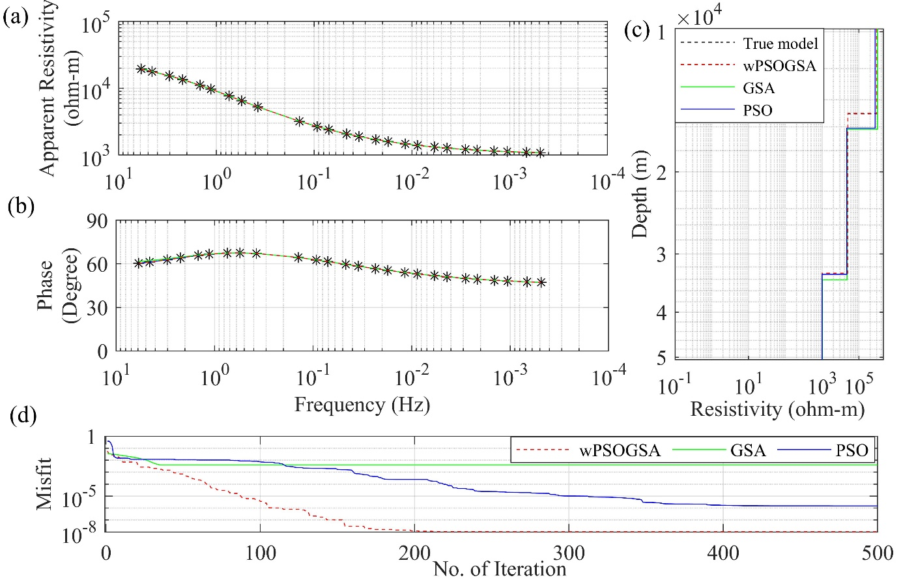

**Figure 1.** The inverted MT response by PSO (blue color), GSA (green color), and hybrid wPSOGSA (red color) with true model (black color) over three-layer synthetic data as shown in (a) observed and calculated apparent resistivity curve, (b) observed and calculated apparent phase curve, (c) 1D depth inverted model, and (d) convergence curve i.e., error versus iterations.

1. For posterior PDF analysis, load the saved data files for statistical analysis and execute posterior.m which returns the global/ mean model and uncertainty in the model parameter.

For examples:

dim=5; %%%%%% No. of parameter

run=10; %%% No. of model or run

percentage=68.27; %%%confident interval

threshold=0.0001;% threshold error

%%load files: r_obs, GlobalBestCost_run, gbest_run, r_cal_PG

r_obs % synthetic apparent resistivity

ac68_pos % mean of best model under 68.27% confident interval

bc68_pos % standard deviation of best model under 68.27% confident interval

The output is saved in the “Output files” folder. For example, the mean model and standard deviation output of wPSOGSA is store by the name “ac68_pos.mat” and “bc68_pos.mat” or in “.mat” format respectively.

The output figure is showing below for three Layer example:

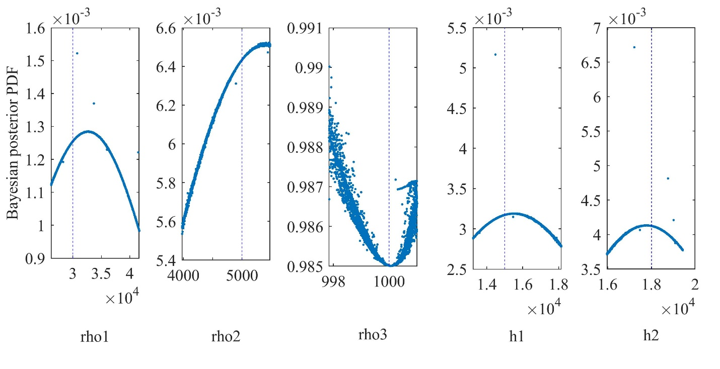**Figure 2.** Bayesian posterior probability density function (PDF) with 68.27% CI for wPSOGSA for three layered synthetic data

1. To read or analyze the output data in the subfolder Output files of Hybrid Algorithm wPSOGA user first load the .mat file by using matlab command “load(‘filename.mat’)”

For example: load(‘ac68_pos.mat’)

Please contact to the author before any modification in the MATLAB code or any assistance.

Matlab function of source files are:

**synthetic.m** % Used for generating data for 1D magnetotelluric model

**psogsa_mt.m** % Main file used for running wPSOGSA algorithm and setting parameters as per user choice

**PSOGSA.m** % calling file, which hold inversion code of wPSOGSA

**initialization.m** % calling file, that initializes random variables within the search ranges for starting the optimization

**benchmark_functions.m** % calling file to calculate cost function

**forward.m** % Calling file for calculating forward model

**RMS_1.m** % calling file for calculating root mean square between calculated data and observe data

**posterior.m** % Main file used for calculating posterior Bayesian PDF and gives mean with uncertainty of inverted data

**post.m** % calling file used in **posterior.m**

**General Reading**

MATLAB® User Guides, External Interface,

<https://in.mathworks.com/support.html?s_tid=gn_supp>